**Final Report**

**For**

**You Pick**



**Teammates: Enrique Penaloza**

**Collaborate with: FridID**

**December 4, 2016**

**Abstract**

“You Pick” is a mobile application that will help the user choose a restaurant destination using simple screen interactions on an easy to follow user interface.

**Table of Contents:**

**1. Introduction** ……………………………...…………………………....……….…….. 3

1.1 Motivation/ Background ………………………………………………….…. 3

1.2 Planned end product ……………....…………………………...……....…...... 3

1.3 Current end product ……………………………………………………......... 3

1.4 Explanation of differences …………............................................................... 3

**2. Technical Documentation** ……………………………………………………....….... 3

2.1 Software Design ………………………………………………………..….… 4

2.2 Tools Used ………………………………………………………………..…. 6

2.3 Dependencies/ Assumptions ……………………………………………….... 6

**3. Evaluation** ……..………………………………………………………………….….. 7

3.1 Test Plan…………………………………………………………….…….….. 7

3.2 Testing Conducted ……………………………………………………..…..... 7

3.3 Results of testing …………………………………………………………….. 7

**4. Future Work** …………………………………………………………………….….... 8

4.1 Where can this product go in the future? ……………………………………. 8

4.2 What are the next steps for your project if you were to continue working on it? …..……………………………………………………………………………………….. 8

**1. Introduction**

**1.1 Motivation/ Background**

For my Senior Project I wanted to develop something not for the purpose of it being completing a senior project, but something I would use for then. Almost every time I am in a car with a friend or two, we always can’t decide where we want to eat. Someone would look into Yelp and decide back and forth if this would be the place to eat but would change their mind because of one bad review and on goes the process all over again.

Using my past experience with going forth this consistent experience I decided for my senior project, I would build and create an app that I could give to my friends or passenger to use to decide on where they’ll want to eat rather than driving around in circles.

**1.2 Planned end product**

I was looking forward on having at least two group members, but I was late to give forth my planned final project. The group resided with only me in the group. With the resources provided, the one-man team can promise to deliver a thorough plan on the design patterns using UML diagrams, user interface diagrams of the mobile application, and feedback on the intent product under evaluation. If given the two group members, I would promise to deliver and complete an active mobile application. Value for this app is negotiable.

**1.3 Current end product**

I managed to complete the software requirements for the mobile application, its user interface module, state diagram, UML diagram, and its User Manual. I did get half of the mobile application developed using Android Studio’s but I needed at most two days to fix errors giving when I would add images into the android code.

**1.4 Explanation of differences**

Issues along the way started with the schedule I had initially made. I was on target on completing the Android Application with all of the documentation completed but when it was time to code the mobile application, I didn’t consider the troubleshooting and debugging if it were to happen. I should have given myself an additional two weeks of coding in my schedule. Lesson learned.

Another issue was coding errors in general. I followed step-by-step on adding images from the computer files to Android Studio’s, but errors occurred one after the other.

**2. Technical Documentation**

**2.1 Software Design**

The mobile application has 2 types of functions: interactive function and input function.

All of the functions are listed below:

* Login Button
* Use location Button
* Use address Button
* Type Address type-in box
* Use location_agree Button
* Swipe Restaurant navigation
* Compare Restaurants double-tap
* Direction_Confirm Button.

The Login Button:

* The purpose of this function is for the user to notice the icon of You Pick and start the process of deciding on where to eat.
* This function is displayed automatically when the app is beginning to run.
* The user taps the screen to deliver an animation of the icon being pressed as a button.
* The button needs to be pressed in order to go to the next screen/phrase.

The Use location Button/ Use address Button:

* The purpose of these functions is when the user would like to choose to use their location to designate the list of restaurant available or use a specific location of an address to list the restaurants available in that location.
* The user treats these two as buttons to make a decision on what method they prefer to use.
* The user taps their screen in their mobile to make a decision.
* Both options take separate phases complete their decision but return to the same screen once they have agreed or typed in their address.
* If the user tapped, “Use address”, it would process them to the next screen to have them type in their address.

The Use location_agree Button

* The purpose of this function is to confirm that the user would like to use their location to refer to restaurants nearby.
* User taps either the yes or no button.
* If the user taps the yes button, the mobile app will process to the next phase, which results to screening the available restaurants. If the user taps the no button, then user will have to manually type in the address of where they are located.
* If the user taps the no button, then it will show the same screen as they were to type in the “Type Address” button.

The Swipe Restaurant navigation

* The purpose of this function is for the user to navigate through the list of available restaurants one-by-one.
* The user swipes left to see the next option and swipe right to go back to the previous option.
* If the user swipes all of the available restaurants, as the user swipes right, the visual effect of the current restaurants icon will present the same result. Vise versa if the user swipes left.
* Alternative swipe functions are swiping up and swiping down.
  + If the user was to swipe up on the current restaurant, the information of that restaurant will be saved in a queue waiting for the user if their initial choice is where they want to eat.
    - If the swipes up on another restaurant, both restaurant will be side-by-side for comparison for the user to choose between the two.
  + If the user swipes down, then the name of the restaurant will be used as a filter to not display the same name of the restaurant for future searches in this session.
* This function is only available once all the input data for the location segment is confirmed.

The Compare Restaurants double-tap

* The purpose of this function is to have the user choose between the two restaurants they swiped up for saved locations.
* This function will only appear once the user has swiped up twice on different restaurants.
* On top of the designated restaurants, there will be a blue ‘X’ marker that can cancel the pick chosen and bring up a “Direction_Confirm” button that asks the user for permission to use the default navigation system in their Android Phone.
  + If the user says no, it will bring the user back to the initial swiping screen with the remaining restaurant till saved in the queue.

The Direction_Confirm Button.

* The purpose of this function is to confirm and inform the user if You Pick can access their Android mobile default navigation to start their navigation to the restaurant chosen.
* The user taps either the “Yes” button or “No” button reading, “Do you wish for You Pick to access your navigation system to arrive at destination?”.
  + If the user taps “Yes” it will bring up the navigation system embedded in their Android phone.
  + If the user taps “No” it will send the user back to the swiping screen refreshing with updated content.
* This function is only available once the location data is fulfilled and the user has double tapped the restaurant of their choosing.

The Type Address type-in box function:

* The purpose of this function is for the user to type in their address for You Pick to locate surrounding restaurants.
* The user taps into the white space inside the box that refers to the address, city, and state.
* The user can tap either their return button under their screen keyboard to proceed to the next white space or can tap the next white space to proceed entering all the information.
* Expected output results into screen on the restaurant’s photo, name, and category of food ethnicity.
* This function is related to Google’s API database to ensure the location is correct. If the address is unknown, the wrong inputted information would have the surrounding whitespace a red outline. The user can re-type in the information and taps their return key to re-evaluate the information.

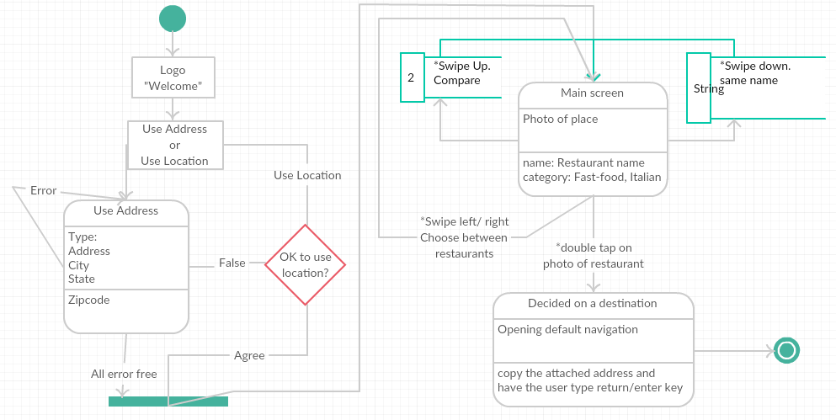

**2.2 Tools used**

Tools used developing the project-required diagrams to be illustrated, using [www.creately.com](http://www.creately.com), and Android Studio’s on developing the actual mobile application.

For the application itself, tools needed to operate the mobile application are

* Android Mobile Phone or tablet that has an Android Operating system 4.1 (“Jellybean”) or higher
* A Google account to grant permission to download within the Google Play store.

**2.3 Dependencies/Assumptions**

Once the application starts up, tap the You Pick Icon on the screen to start the mobile application.

Once the icon is tapped, a new screen appears giving the user to decide whether the to tap in the “Use Address” button or “Use Location” button. If the user taps in the “Use Address” button, the user will be sent to a different screen to have the following information entered manually: Address, City, State. If the user tapped “Use Location” then a new window will appear and ask whether the user gives permission to have You Pick use the address of its location. If the user taps the “Yes” icon, then the application will continue to the next screen. If the user taps “No”, then the application will redirect the user to the screen where they would have to manually type in the address of the location they would like to search around.

As the reference of the location destined is correct, the user can swiftly swipe left or right to navigate through the list of available restaurants one-by-one. If the user has decided their restaurant of choice, they double tap the screen and a box appears to ask permission to use their Android’s Mobile default navigation system. If the user taps “Yes” then the navigation process starts and You Pick has completed its job. If the user “taps” no, the application will return the user back to the screen it left off.

If the user swipes up, navigating through the available restaurants, the information of the exact restaurant is saved in a queue waiting for the user to continue their search or clicked at if the user decides to go with their first choice. If the user swipes up at two different restaurants, then immediately both choices appear side-by-side to distinguish which of the two choices is the user going to choose. The user double taps their choice and the navigation question appears so to complete the process. When the two choices appear side-by-side, both have an ‘X’ at the top of their space margin. If the user taps the ‘X’ on one of their choices, the navigation box appears asking for permission to use the Android’s mobile navigation upon the remaining choice to navigate too.

If the user swipes down when navigating through the list of available restaurants, the program will filter any restaurant that has the same name as the restaurant that gotten swiped down for the rest of the session.

**3. Evaluation**

**3.1 Test Plan**

Android Studio’s has an integrated mobile generator that the user can run and launch a virtual Android phone to test the mobile application. Just like any other programming language, if the code is not compiled, the software application will not run property.

**3.2 Testing conducted**

On every completed You Pick screen layout, testing was conducted between the interaction functions and button functions. Testing was conducted on how an interaction would trigger the next screen layout to proceed to the next mobile screen. Being that the layout of the screen was STATIC, testing the layout was instant. There was testing over a variety of colors to choose from, but it resulted into regular-colored yellow with red-colored text. Overall, most of the testing conducted proceeded with trial and error.

**3.3 Results of testing**

Once the virtual machine, or phone, was running, you would interact with the user interactions using the mouse as your finger. For testing, the logo of You Pick had to be replaced with a regular button to test if the interaction from the greeting page would proceed to the decision of using location screen.

The swipe interaction testing were done on another separate file project which I planned to copy and paste to the original project file. All swiping interactions were a success on going by the screen, but the image bug loomed to which the project had to go into a halt until it was dealt with.

Google’s API clearance for use was easy to obtain. I followed the instructions under a video in YouTube and obtaining the Google API id for development. I however, never got to use the framework due to time management.

**4. Future Work**

**4.1 Where can this project go in the future?**

On the third update, when the mobile application integrates real-time, I could record the time it takes the user to swipe-right, and use that data to record an analytical record of what users want and don’t want based on their behavior against the user interaction. This would lead to investors on the data they need for marketing and potentially sell the mobile application.

**4.2 What are the next steps for your project if you were to continue working on it?**

After final exams from the other classes are done, I plan on working on it during the winter break. I plan on releasing the application before Christmas.

After the initial projected mobile application, You Pick is in the android store for about 3 months, I want to update the software and integrate the machine-learning feature I wanted the mobile application to have. This machine learning within the application will learn on the behavior of swipes the user makes based on the restaurants food genre. This update will probably be available before July, depending on my schedule.

On the third update I want to integrate real-time to record the time it takes the user to swipe determining the analytical record of what users want and don’t want. This update would probably be available till next year, depending on my schedule.